**GENERAL GUIDELINES FOR PROJECT REPORT SUBMISSION**

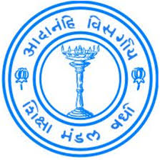

**BAJAJ INSTITUTE OF TECHNOLOGY**

**WARDHA - 442 001 (INDIA)**

**2021 - 22**

**Specimen 'A': Title of Project (add border)**

***Monitoring and Evaluation System for ICCR’s***

***Regional Offices (ROs)***

***Project report submitted to***

***Dr. Babasaheb Ambedkar Technological University, Maharashtra***

***in partial fulfilment of the requirements for the award of***

***the degree***

**Bachelor of Technology**

**In**

**_______________ Engineering**

*By*

**Shreya Chinchmalatpure (2046491245048)**

**Ashwini Ukhalkar(2046491245008)**

**Purva Dhopade (2046491245034)**

under the guidance of

**Abhishek Kinhekar**

**Assistant Professor**



**Department of ______________ Engineering**

**Bajaj Institute of Technology**

**Wardha-442 001 (India)**

**2022-YY**

**Specimen 'B': Certificate**

**BAJAJ INSTITUTE OF TECHNOLOGY, WARDHA**

**DEPARTMENT OF COMPUTER ENGINEERING**

**CERTIFICATE**



***This is to certify that the Project report titled***

***Monitoring and Evaluation System for ICCR’s Regional Offices(ROs)***

***has been successfully completed***

***by***

**Shreya Chinchmalatpure (2046491245048)**

**Ashwini Ukhalkar(2046491245008)**

**Purva Dhopade (2046491245034)**

***in partial fulfilment of the requirements for the award of***

***the degree in Bachelor of Technology, Computer Engineering***

|  |  |
| --- | --- |
| **Abhishek Kinhekar**  **Assistant Professor**  **Guide**  Department of ___________ Engineering  Bajaj Institute of Technology, Wardha | |
| **Sheetal Kale**  **Head of the Department**  Department of ___________ Engineering  Bajaj Institute of Technology, Wardha | **Dr. N. M. Kanhe**  **Principal**  Bajaj Institute of Technology,  Wardha |
|  | |

**Date:**

**Place: Wardha**

**Specimen 'C': Declaration**

**DECLARATION**

I/We, hereby declare that the project report titled “________________________________” submitted by me to the Bajaj Institute of Technology, Wardha, in partial fulfilment of the requirement for the award of Degree of B. Tech. in ___________________ Engineering discipline is a record of bonafide project work carried out by me under the guidance of  **Abhishek Kinhekar (Assistant Professor)**

I/We, further declare that this submission by the undersigned represents my/our original work and I/We have quoted the references where others ideas/words have been included. I understand any violation of the above will levy a disciplinary action on me/us.

I/We, further declare that the work reported in this project report has not been submitted either in-part or in-full for the award of any other degree in any other Institute or University.

Date :-

Place :- Wardha

|  |  |  |  |
| --- | --- | --- | --- |
| **S. No.** | **Name of Student** | **PRN Number** | **Signature** |
|  |  |  |  |
|  |  |  |  |
|  |  |  |  |
|  |  |  |  |

**Specimen 'D': Acknowledgement**

**ACKNOWLEDGEMENT**

**(TEXT)**

Provide correct name & designation

to project guide/s

**(TEXT)**

to Head of the Department of ________________ Engineering

Provide correct name

**(TEXT)**

to the Principal, Bajaj Institute of Technology, Wardha

**(TEXT)**

to all others (if any) especially the name of the firm(s)/companies (if any) if you have collected any data or carried out Project/Internship with them.

Date:

Place: Wardha

|  |  |  |  |
| --- | --- | --- | --- |
| **S. No.** | **Name of Student** | **PRN Number** | **Signature** |
|  |  |  |  |
|  |  |  |  |
|  |  |  |  |
|  |  |  |  |

**Specimen 'E': Abstract**

**ABSTRACT**

This project is an ideal web-based monitoring and evaluation tool for Indian Council for Cultural Relations (ICCR) under Ministry of External Affairs. Ministry of External Affairs’ auspices to carry out programs that promote Indian culture on a global scale. It was founded in 1950 by Maulana Abul Kalam Azad, who believed strongly in developing cultural contacts with different countries and civilizations.

The ICCR focuses on the development and execution of programs and policies that are thoroughly anchored in India's international cultural relations. ICCR's main goal is to encourage international friendship, cultural interaction between nations, healthy competition and exchange, and, as a result, to integrate the modern and ancient aspects of Indian culture. It fosters and strengthen cultural relations and mutual understanding between India and other countries, and in actively participating in the formulation and implementation of policies and programs about India's external cultural relations.

Our web application provides dashboards and options to manage Regional Offices and evaluate their activities based on certain parameters. RO’s (Regional Offices) are provided with a dashboard to schedule activities, upload reports for the activities/events conducted, manage students, handle their grievances etc. and upload financial information regarding the event. A star rating mechanism is proposed to rate the performance of RO's based on parameters of events conduction, international students’ feedback for the facilities provided and local participants feedback for the events conducted by the students.

The ICCR has an Annual Calendar of activities for Regional Office’s (ROs). Here the activities are divided in three different types. ICCR Annual Calendar Activity, Self-Driven Activities, ICCR HQ Driven Activities.

ICCR Annual Calendar Activities are those activities that are the part of ICCR Annual calendar, which should be conducted compulsorily within the institutes.

Self-Driven Activities: Regional Offices are encouraged to conduct self-driven activities to promoting regional culture within their stats and areas.

ICCR HQ Driven Activities: The ICCR HQ at national level may also conduct activities different from Annual Calendar, RO’s will participate in those activities and upload its report.

**Specimen 'F': TOC**

**TABLE OF CONTENTS**

|  |  |  |
| --- | --- | --- |
| **Chapter**  **No.** | **Title** | **Page No.** |
|  |  |  |
|  | Certificates | i |
|  | Declaration | ii |
|  | Acknowledgement | iii |
|  | Abstract | iv |
|  | Table of Contents | v |
|  | Abbreviations | vii |
|  | List of symbols | viii |
|  |  |  |
| **1** | **Introduction** | 1 |
|  | 1.1 (Decide subtitles appropriately) |  |
|  | 1.2 |  |
|  | 1.3 Organization of report |  |
|  |  |  |
| **2** | **Literature Survey** | 2 |
|  | 2.1 literature review |  |
|  | 2.2 Gap identification in Literature |  |
|  | 2.3 problem statement |  |
|  | 2.4 objective |  |
|  | 2.5 Scope of work |  |
|  |  |  |
| **3** | **Methodology / Study Report / System Requirements And Specifications** | 3 |
|  | 2.1 (Decide subtitles appropriately) |  |
|  | 2.1.1 sub process 1 |  |
|  | 2.1.1.1 sub process 2 |  |
|  |  |  |
| **4** | **Implementation of Project / (Use Appropriate Heading)** | 4 |
|  |  |  |
| **5** | **Results and Discussions** | 5 |
|  |  |  |
| **6** | **Conclusions and Future Scope/ Summary** | 6 |
|  | 5.1 Conclusions / Inferences |  |
|  | 5.2 Future Scope |  |
|  |  |  |
|  | **References** | 7 |
|  |  |  |
|  | **Annexure A** | 8 |

**Specimen 'I': List of Abbreviations**

**ABBREVIATIONS**

**Examples**

|  |  |
| --- | --- |
| *NHAI* | National Highways Authority of India |
| *PMGSY* | Pradhan Mantri Gram Sadak Yojana |
| *CRRI* | Central Road Research Institute |
| *MORTH* | Ministry of Road Transport and Highways |

*(Abbreviations should be in italics)*

**Specimen 'J': List of Symbols**

**LIST OF SYMBOLS**

**Samples**

|  |  |
| --- | --- |
| *P* | Design wheel load (half of the single axle load/one-fourth of the tandem axle load) |
| *h* | Pavement thickness |
| *L* | Length of the slab panel |

*(Symbols should be in italics)*

**Specimen 'K': Chapters**

**CHAPTER 1**

**INTRODUCTION**

The Online Monitoring and Evaluation System for ICCR’s Regional Offices (ROs), would monitor all its Regional Offices in India on real-time basis for all the activities conducted. This will help ICCR to implement its activities effectively and thus, evaluate their performances in real-time. Its objectives are to actively participate in the formulation and implementation of policies and programmes pertaining to India's external cultural relations; to strengthen cultural relations and mutual understanding between India and other countries; to promote cultural exchanges with other countries and people, and to develop relations with nations.The aims and Objectives of the ICCR are as follows:

* To participate in the formulation and implementation of policies and programs relating to India’s external cultural relations.
* Fostering and strengthening cultural relations and mutual understanding between India and other countries.
* to promote cultural exchange with other countries and peoples
* to promote and strengthen cultural relations and mutual understanding between India and other countries
* Establishing and developing relations with national and international organizations in the field of culture.

The intended audience who will be mainly using our system are:

ICCR, ROs, Institutes and Students.

* ICCR is the primary stakeholder with a separate dashboard to manage Regional Offices and evaluate their activities.
* RO’s will be provided with a dashboard to schedule activities, upload reports for the activities conducted and manage students and handle their grievances.
* Institutes will be provided funds by the ICCR to conduct cultural events at the institute level.
* Students can give feedback of the events conducted in their institutes.

Some of the important features in our web application would be Monitoring and evaluating all activities of ICCR’s Regional Offices and evaluate their performances on real-time basis. Look after the interest of foreign students studying in various states of India. Keep track of Monetary Information spent on students and other establishment expenditure. Develop mechanism to coordinate with local cultural and educational organizations and the State Government for carrying out ICCR’s based activities.

**CHAPTER 2**

**LITERATURE SURVEY**

**“Indian Council for Cultural Relations – Overview”**

* The Indian Council for Cultural Relations (ICCR), is an autonomous organisation of the Government of India. There are other bodies in Government of India.
* ICCR is involved in India’s external cultural relations or cultural diplomacy, through cultural exchange with other countries and their peoples. It works to strengthen cultural relations and promote mutual understandings.
* The Council’s activities are overseen by its three statutory bodies – General Assembly, Governing Body and Finance Committee.
* Indian Council for Cultural Relations holds various ICCR Scholarships and Orientation programmes. The courses offered for studies are for under-graduation, post-graduation and M. Phil /PhD levels. It also holds Summer and winter camps.

**“Indian Council for Cultural Relations, Government of India : Feedback”**

Describes the feedback mechanism, in the form of feedback form ,where the international students and local participants will fill the feedback form and give suggestions about the event which can be used to improve the quality of the events.

**“Indian Council for Cultural Relations, Government of India : Scholarship”**

It gave detailed information about the different types of scholarships given to the foreign students who wish to gain knowledge of the Indian culture where ICCR has announced 100 Scholarship slots globally under the “ICCR Scholarship for Indian Culture” (A1209) for pursing study of Indian Culture such as dance, music, theatre, performing art, sculpture, Indian languages, Indian cuisine, etc

**“Indian Council for Cultural Relations, Government of India: Report”**

The Regional Offices and Institutes will upload reports to Centralized System mentioning all the information related to conduction of event along with geo-tagged photos and financial expenditure report.

**“Indian Council and Cultural Relations – Significance”**

* It provides a platform to promote Indian art, theatre, instrumental and vocal music of the Carnatic and Hindustani genres and folk art forms to audiences abroad.
* It encourages active discussions and interaction between scholars and those interested in Indian languages, culture and heritage by organizing Seminars, Conferences and Workshops abroad.
* Creates an endearing and everlasting image and promotes India’s soft power overseas through dissemination of its heritage, values and philosophy.

ICCR Awards & Honours

* The Indian Council for Cultural Relations has instituted several awards, which are conferred upon the foreign nationals for their contributions in different fields, under its mandate of promoting India’s cultural relations with other countries.

1.Gisela Bonn Awards- The Annual Gisela Bonn Award was instituted in 1996 by ICCR in the honour of famous German journalist, writer, environmental activist and Indologist, Gisela Bonn. The Award is annually conferred upon a German national for his/her contribution towards the promotion of Indo-German Friendship.

2.ICCR Distinguished Alumni Award – instituted in 2015, the award is conferred upon foreign nationals who have studied in India, and have contributed to the promotion of understanding, goodwill and friendship between India with people of their countries.

3.Distinguished Indologist Award – The annual “ICCR Distinguished Indologist Award” was instituted in 2015 during the First World Indology Conference hosted in India. Award is conferred upon a foreign scholar for his contribution in the study, teaching and research in any of the fields of Indian Studies.

4.World Sanskrit Award –The institution of annual “World Sanskrit Award” was announced during the 16th World Sanskrit Conference held in Bangkok in June 2015 recognizing the contribution of foreign scholars in promoting Sanskrit studies.

**CHAPTER 3**

**METHODOLOGY/STUDY REPORT/SYSTEM REQUIREMENTS AND SPECIFICATIONS**

It is a web portal with separate dashboards for each stakeholder ICCR, ROs, Institutes and Students whose main objective is:

* ICCR

ICCR is the primary stakeholderits main objective is to monitor all its Regional Offices (ROs) in India on real-time basis for all the activities they conduct, which would ultimately help ICCR to implement its activities effectively and efficiently and thus, evaluate their performances on real-time basis.

* INSTITUTE

Institutes will be provided with a dashboard to schedule/plan activities given by ICCR and RO’s and some Self Driven Activitiesand upload Financial information and Report required for audit of an event etc. Institutes will also be provided with funds by the ICCR to conduct cultural events at the institute level.

* REGIONAL OFFICES

RO’s (Regional Offices) will be provided with a dashboard to schedule/plan activities, upload reports for the activities/events conducted (photos, videos, attendance and feedback), manage students (stipends, claims, HRA etc.), handle their grievances etc. and upload Financial information required for audit of an event etc.

* STUDENTS

Students will also be provided with dashboard where they will be able to manage their profile, apply for scholarship and view scholarship status, view academic information, file grievance. They can even participate in events and give feedback of the events conducted in their institutes.

## Functional Requirement

REQ-1: Login for the stakeholder:

All the stakeholder will separate login.

REQ-2: Stakeholder will be provided with separate dashboard.

REQ-3: Monitoring and Evaluation of reports:

All the monthly reports provided by the RO will be helpful to monitor whether the activities are properly conducted or not and would be evaluated by the ICCR.

REQ-4: Rating mechanism:

The RO and institutes will get ratings after evaluation of the reports.

REQ-5: Evaluation by RO:

* The RO would evaluate the report submitted by the institutions and provide funds to conduct more of such activities.
* RO will get all the details of the activity conducted in the report.

REQ-6: Student module:

* + Student will get all relevant information of upcoming activities.
  + Student can also get information of previous activities.
  + Applications for scholarship would be made available to the students.
  + Feedback form for the activity would be provided.

# **Non-functional Requirements**

## Performance Requirements

* The report uploaded by the Institution or RO should not be larger than 50 MB.
* Smooth working of website is must to ensure good user experience.
* Server will be working 24X7.

## Safety Requirements

* Access to unauthorized student would be prevented.
* Student will not be a part in making or editing activity report.
* No one other than RO and ICCR would have access to institute reports.

## Security Requirements

* Access to unauthorized student would be prevented, same for the Institute as well.
* Student should be enrolled in the institute to fill the feedback form and apply for scholarship.
* Only authorized student would be able to apply for scholarship and fill the feedback.
* Only ICCR would have access to monitor and evaluate the monthly activity reports of RO.

## Software Quality Attributes

* Map is an additional feature that provide information of RO’s in India.
* The System is easy to maintain.

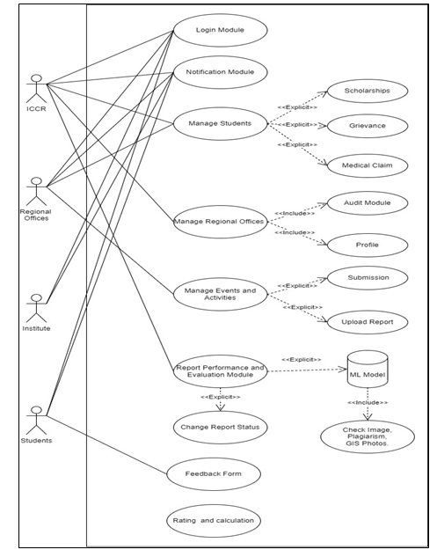

Fig. 3.1 Use Classes and Characteristics

**CHAPTER 4**

**IMPLEMENTATION OF PROJECT / EXPERIMENTAL SETUP / (use appropriate heading)**

**APP.JS**

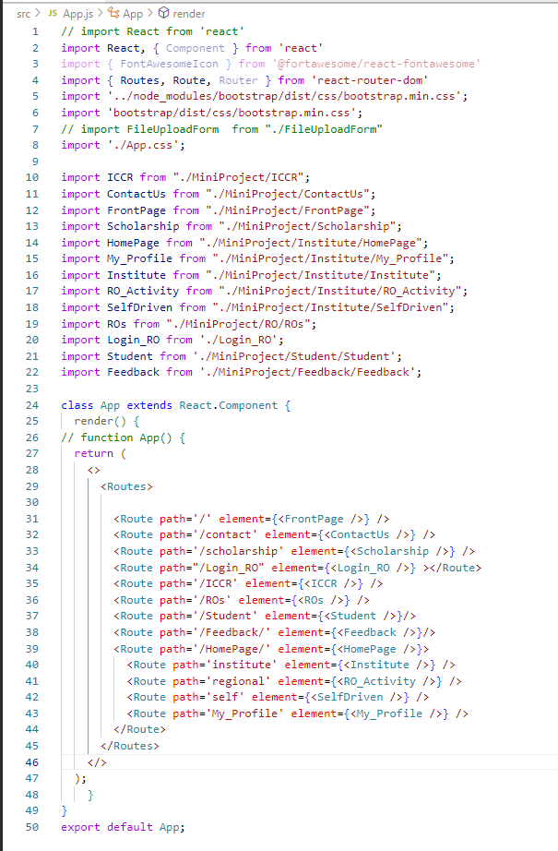

FrontPage of ICCR Website

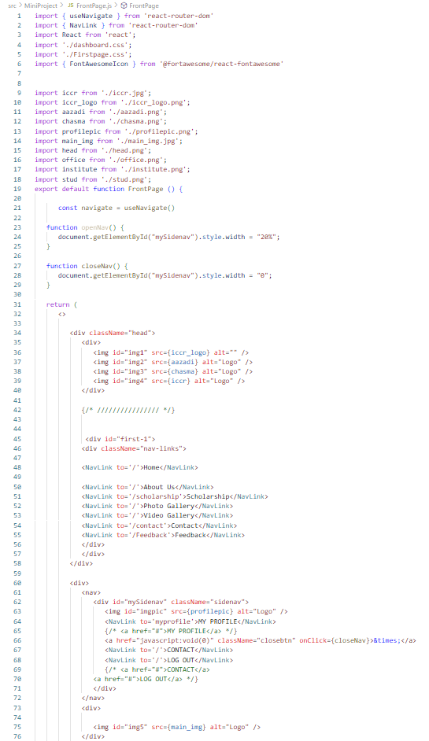

FrontPage of INSTITUTE Website

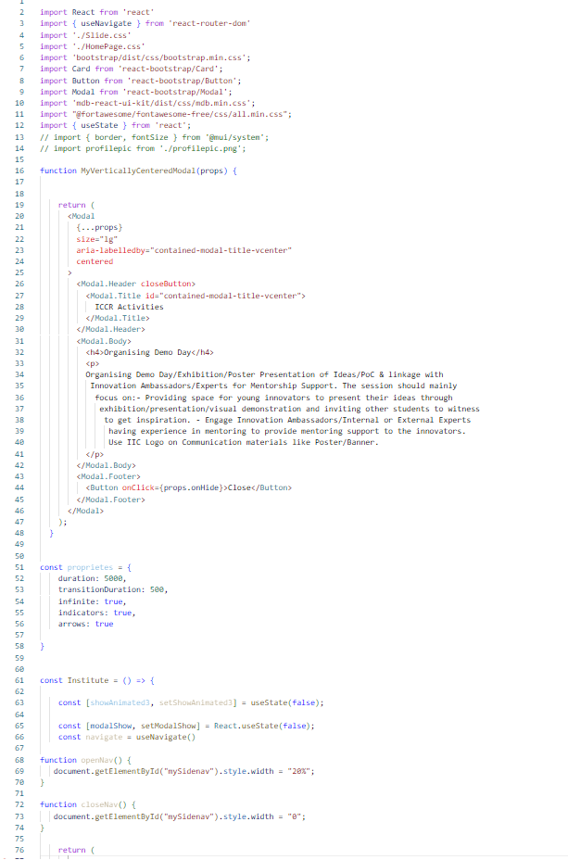

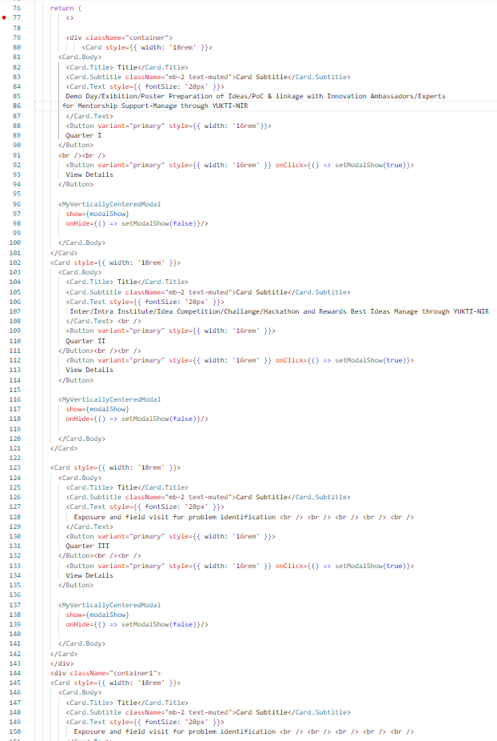

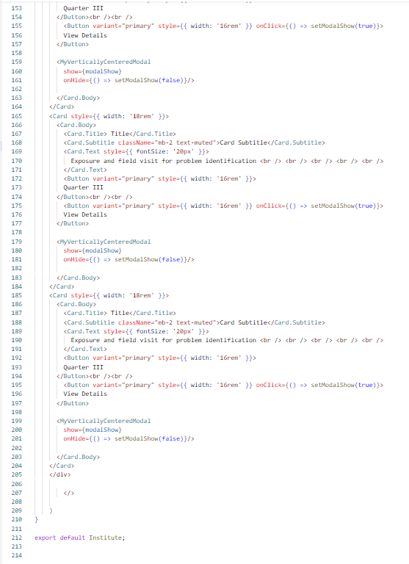

FrontPage of Regional Office Website

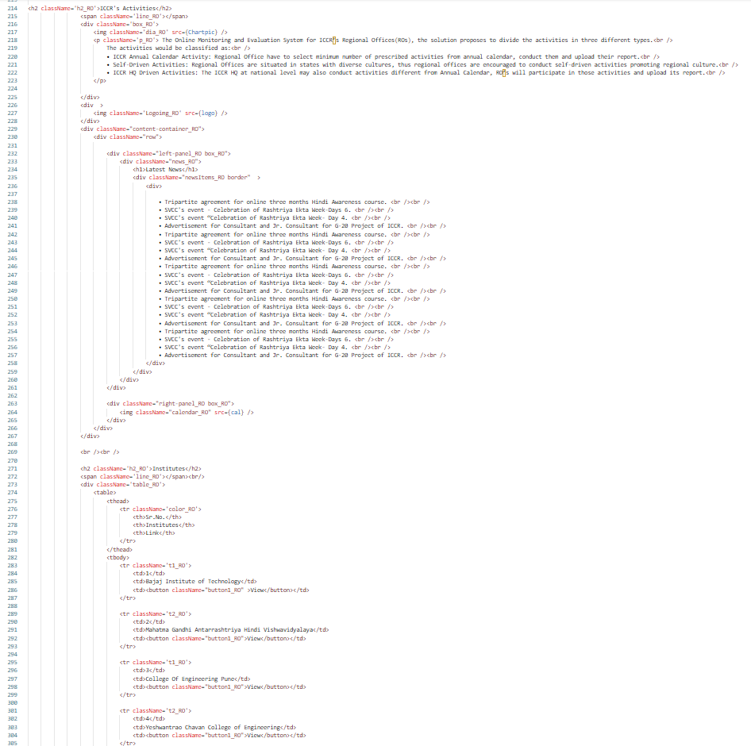

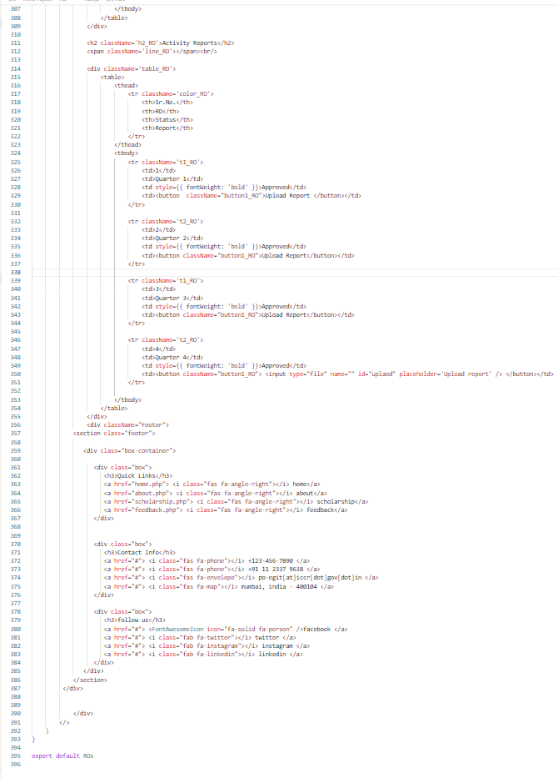

FrontPage of STUDENT Website

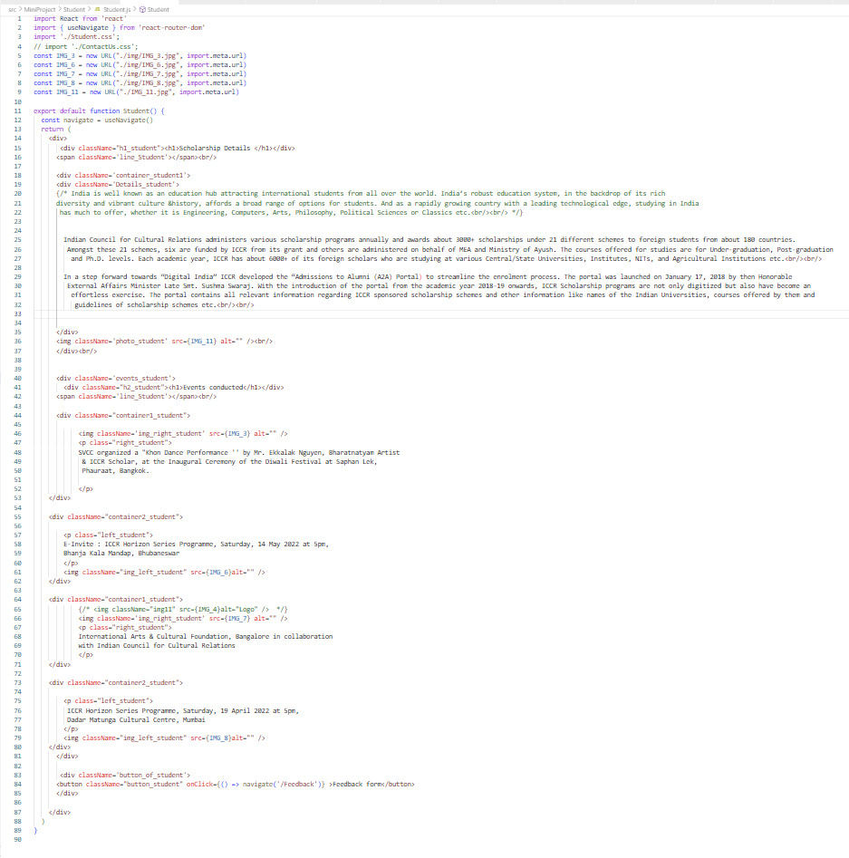

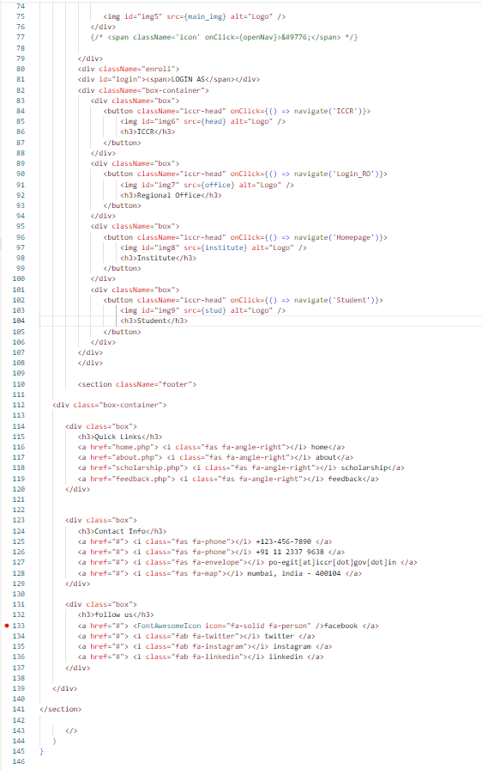

**CHAPTER 5**

**RESULTS AND DISCUSSIONS**

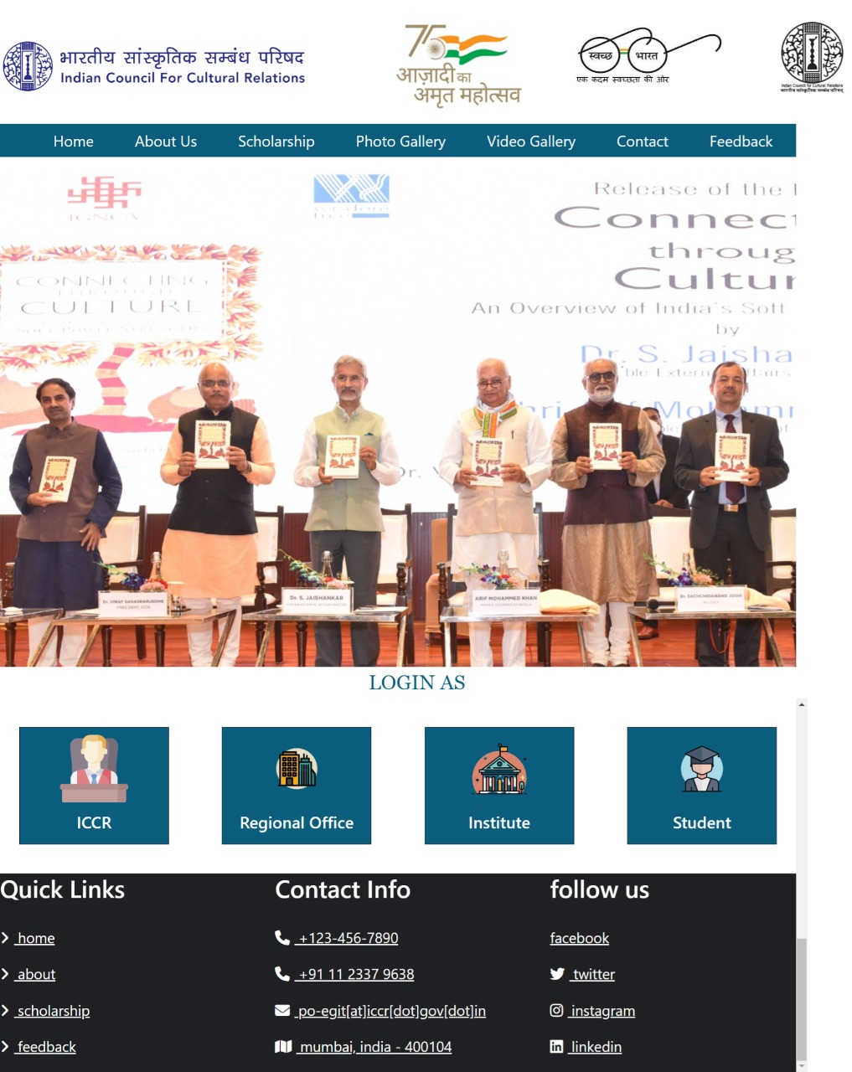

**Fig. 5.1**

**Frontpage of system**

It contains the login for all the stakeholder. When we click on ICCR it directs the user to the webpage of ICCR. Similarly, when clicked on regional office or institute or student it will be directed to that page.

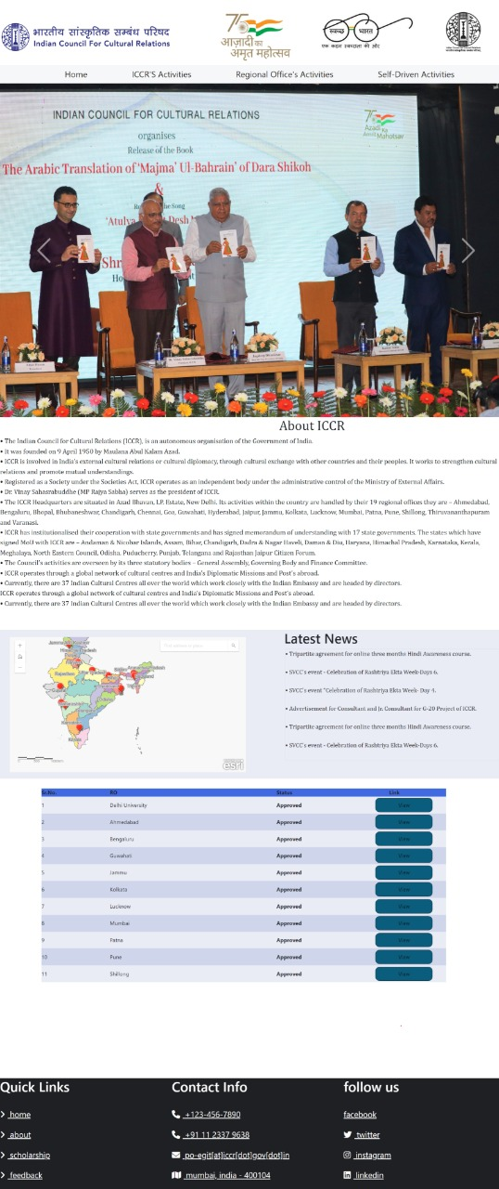

**Fig. 5.2**

**Webpage of ICCR**

This is the webpage of ICCR. It contains some information about ICCR followed by a map on the left displaying the RO’s on it and latest news on the right side. The table in the figure shows the RO’s approval status and an option to view RO.

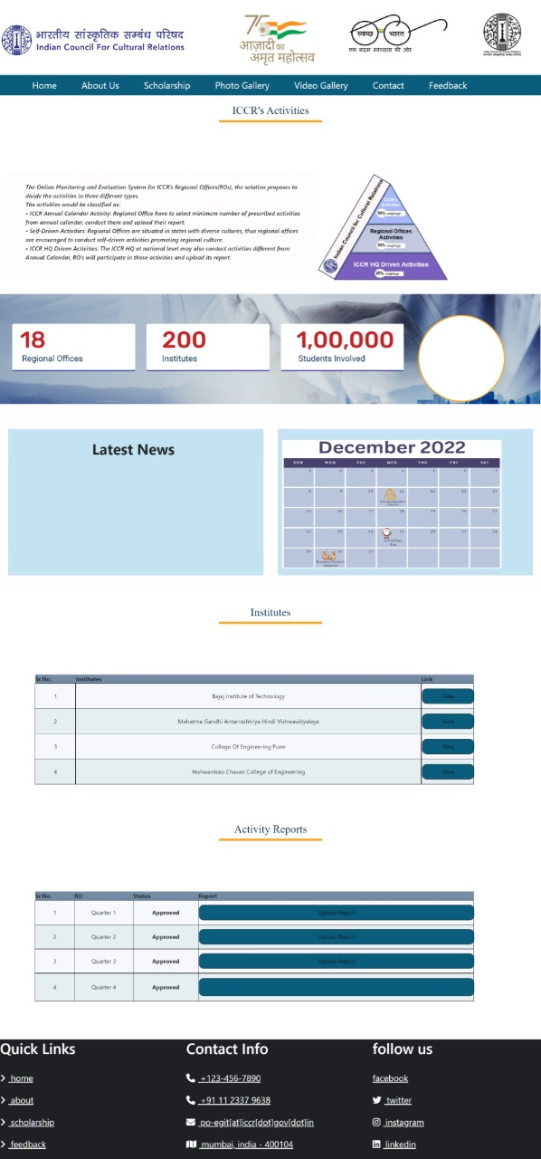

**Fig. 5.3**

**Webpage of RO**

This is the webpage of RO. It includes information about RO, latest news and academic calendar of activities to be conducted. It also includes list of institutes under the RO. In the activity reports table, the RO will submit the quarterly reports by clicking on upload reports which will be then monitored by ICCR.

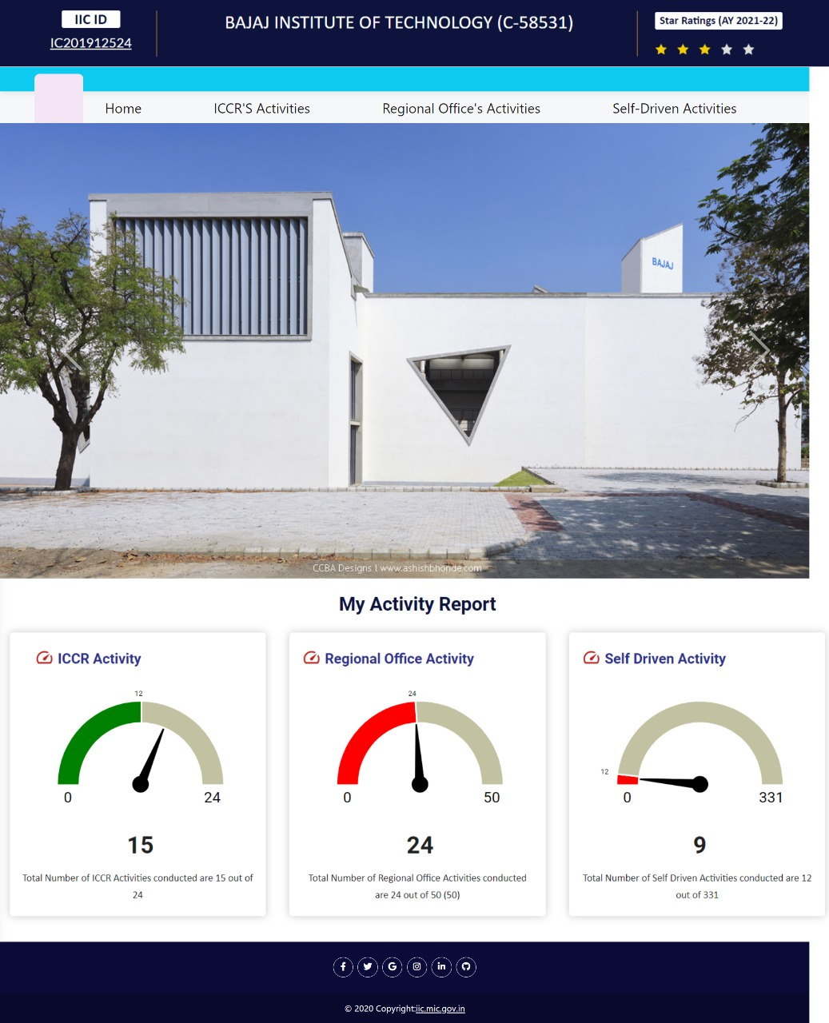

**Fig. 5.4**

**Webpage of Institute**

This is the webpage of Institute which is under RO. After clicking on any of the following- ICCR’s activity, Regional Offices activities or self-driven activities the page will be directed to the activity page given below.

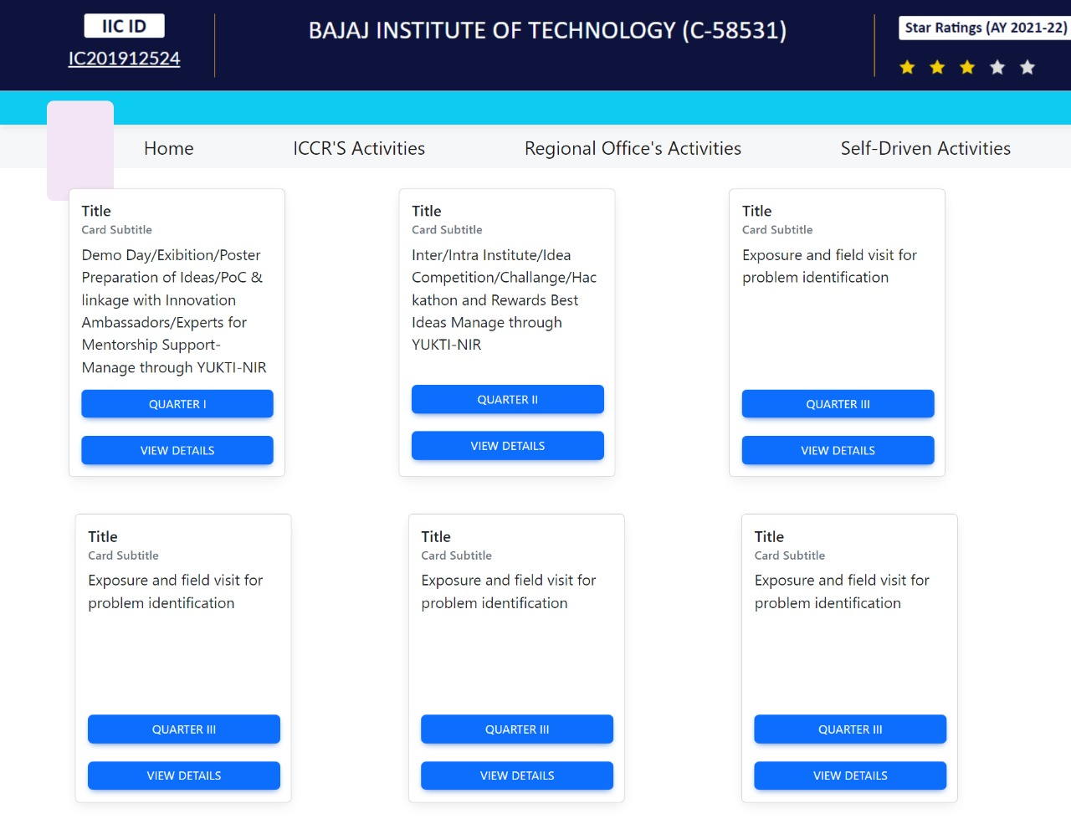

**Fig. 5.5**

**Webpage of activities**

This webpage shows the activities which need to be conducted by the Institutes. On clicking on view details, it will give the detail view of activity to be conducted as of how to conducted the activity, what is need to conduct this activity, what documents need to be produced etc.

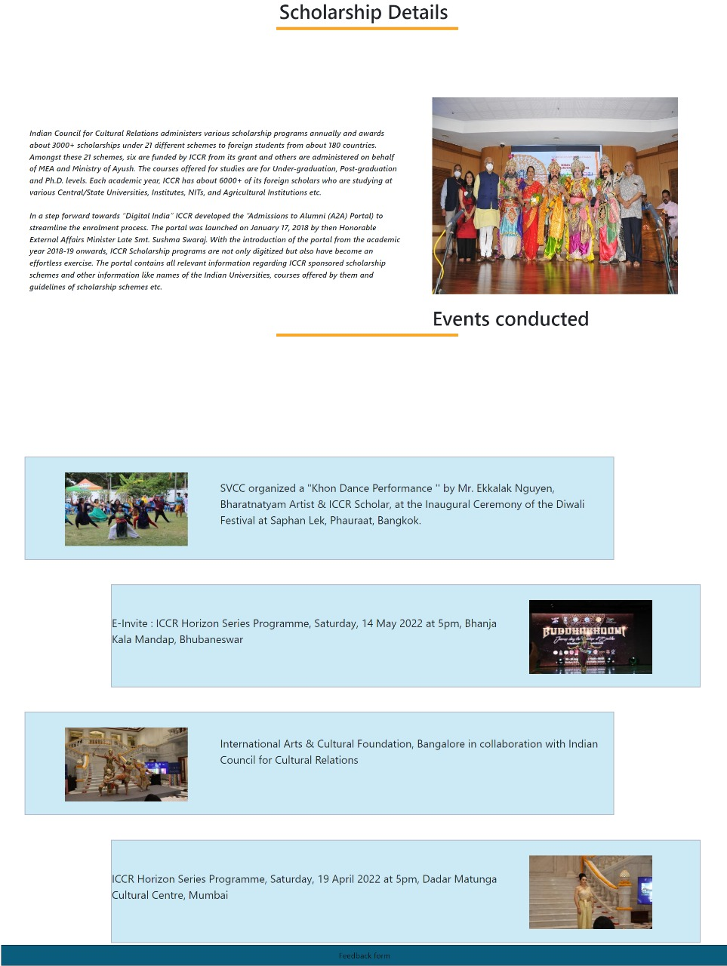

**Fig. 5.6**

**Webpage for Students**

The webpage for students contains scholarship details for students. It also contains information of previously conducted activities/events and feedback form as shown below to get feedback from the students about the activity. It will help institute to conduct better activities further.

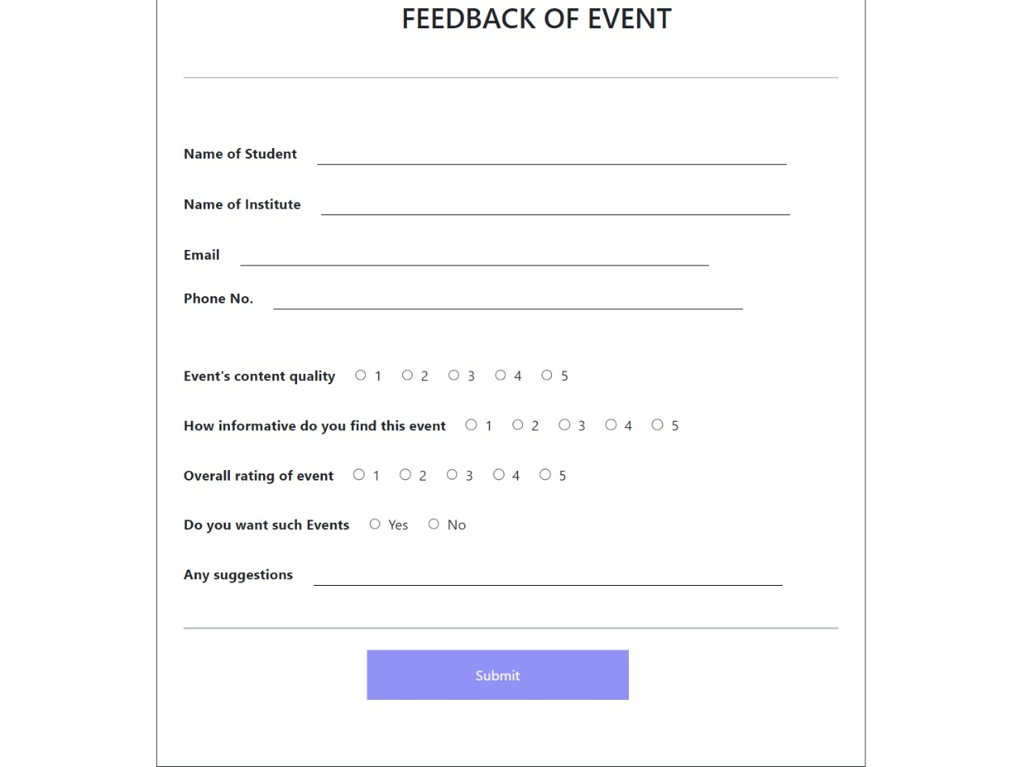

**Fig. 5.7**

**Feedback form**

**CHAPTER 6**

**CONCLUSIONS AND FUTURE SCOPE / SUMMARY**

The outcome of our project is that we were able to create the monitoring system to monitor the activities of regional offices under Indian council for Cultural Relations. Thus, we conclude that this website will help ICCR to monitor activities performed by regional offices and help them rate their performance. The website will also help to generate Monthly & Annual Activity Reports.

The feedback received from international students will help ICCR devise better student friendly policies, thus improving students participation in cultural activities. The monitoring and evaluation system helps to look after whether the activities conducted to convey Indian culture are done correctly and precisely or not.

This website indirectly helps the ICCR to foster and strengthen cultural relations and mutual understanding between India and other countries and helps to promote cultural exchanges with other countries and people, and to develop relations with nations. The cultural exchanges help in overall development of individual and society.

In future we can extend this project to include star rating mechanism to evaluate the activities of RO’s. The rating mechanism include distributing points to every activity conducted and hence converting the points into stars and rating the RO’s. This evaluation will the RO improve the execution of activities and promote cultural exchange more effectively.

**REFERENCES**

* Indian Council for Cultural Relations, Wikipedia, [https://en.wikipedia.org/wiki/Indian_Council_for_Cultural_Relations#Publications](https://en.wikipedia.org/wiki/Indian_Council_for_Cultural_Relations), Oct 3,2022
* Official website of Indian Council for Cultural Relations, Government of India, <https://iccr.gov.in/about-us>, Oct 3,2022
* ICCR Annual Report: Indian Council for Cultural Relations Azad Bhawan, I.P. Estate, New Delhi, 2020-21

**ANNEXURE A**

Appendix A: Glossary

ICCR: Indian Council for Cultural Relations.

RO: Regional offices.

Activity: Events, work determined by ICCR.

Appendix B: Analysis Models

